CIR - Search Methodology

How to use CIR?

Steps:

- Open the website and sign in with user id and password:

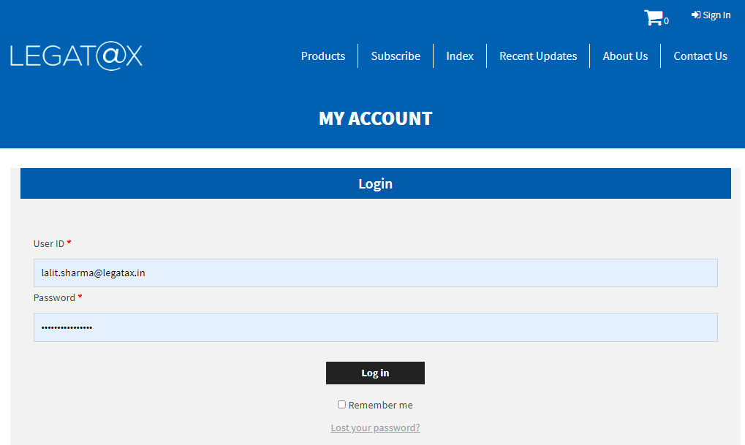

- Select the product CIR:

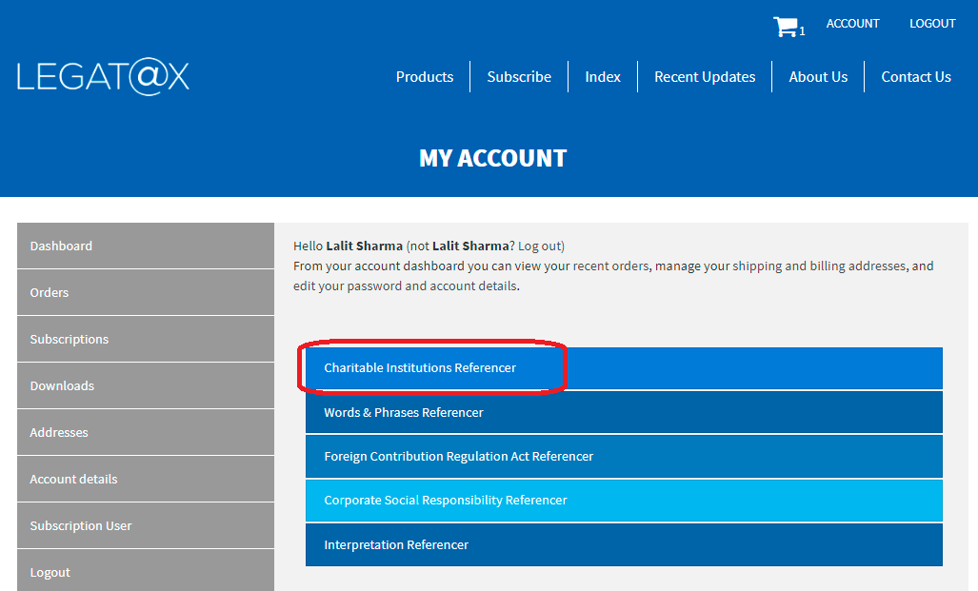

- CIR home page will appear as follows:

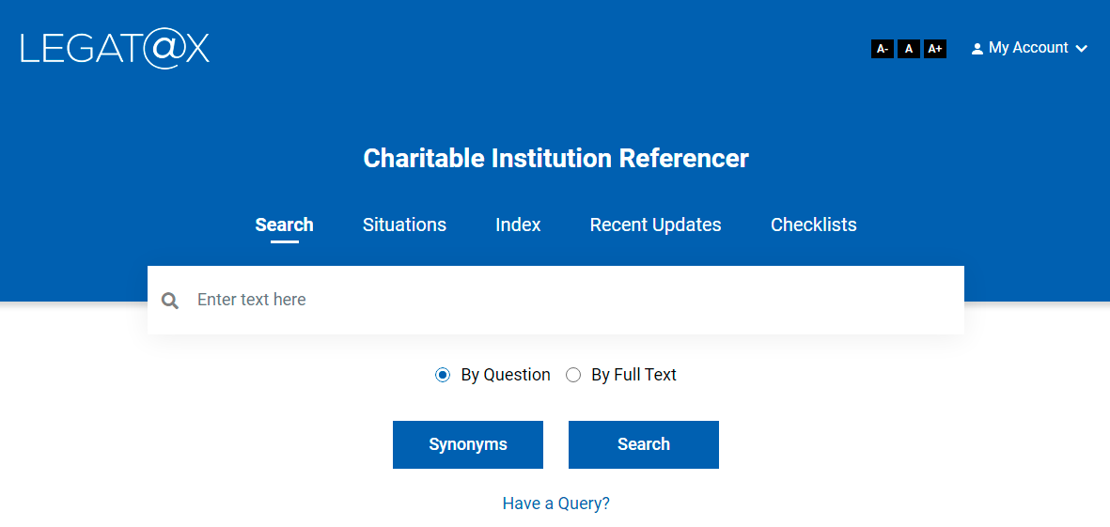

- As seen on the home page, a search can be conducted by

- Situations
- Index
- Checklists
- By Question
- By Full Text

- Search by Situations:

This contains the list of various situations which may be faced by a charitable institution (e.g. implications upon earning capital gains, implications upon utilisation of corpus donation, implications if 85% of income not applied, etc.). A click on a particular situation will show summarised but holistic implications in relation to that situation, with links to detailed explanation.

Illustration:

  - To search the first situation given above, take ‘capital’ as keyword and search it on ‘Situation’ page:

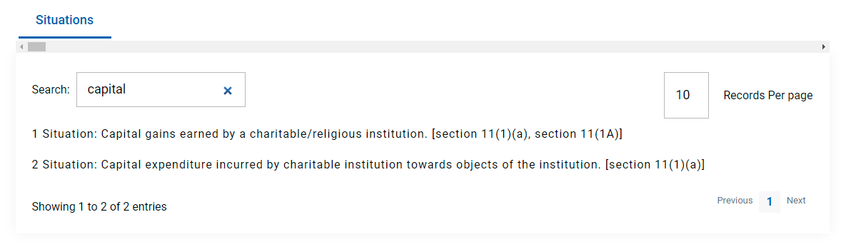

  - In above search result, relevant situation is ‘1 Situation’. A click on it will show summarised but holistic implications in relation to that situation, with links to detailed explanation as follows:

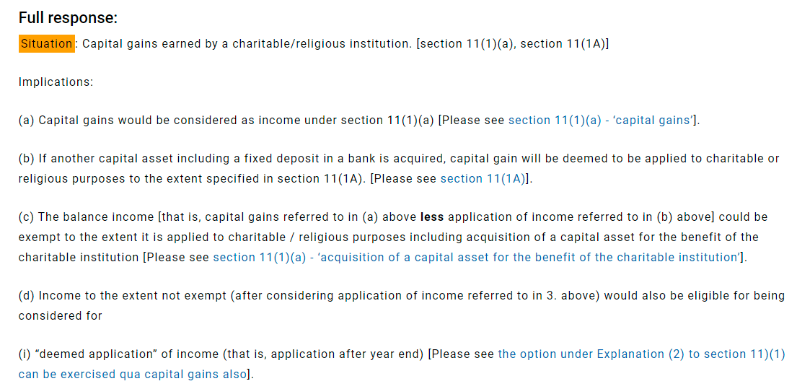

- Search by Index

This contains the list of topics under which all the content is classified (e.g. Relief of poor, education, medical relief, yoga, etc.). If you wish to read everything on a topic, search by index. A click on a particular topic will open the content relating to that topic.

Illustration:

  - To read the topic on ‘education’, type the word ‘education’ as keyword and search it on ‘Index’ page:

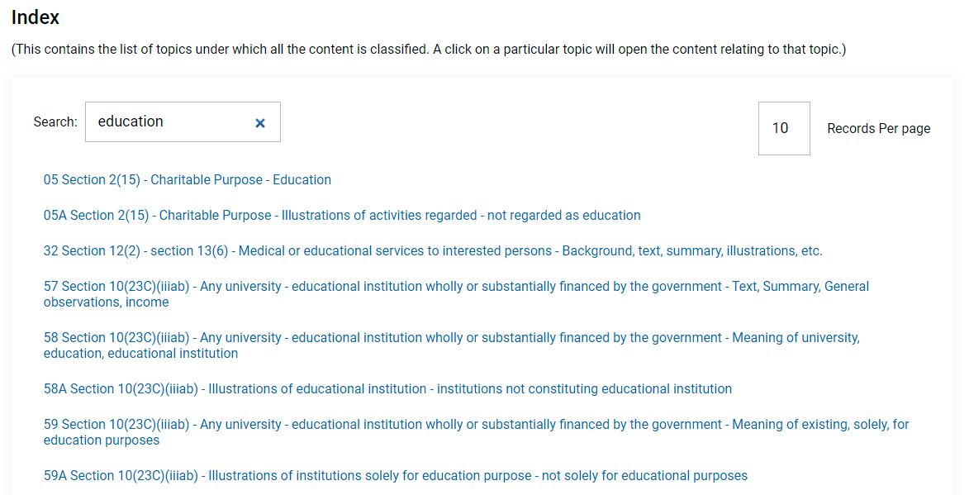

  - A click on education will open the topic as follows:

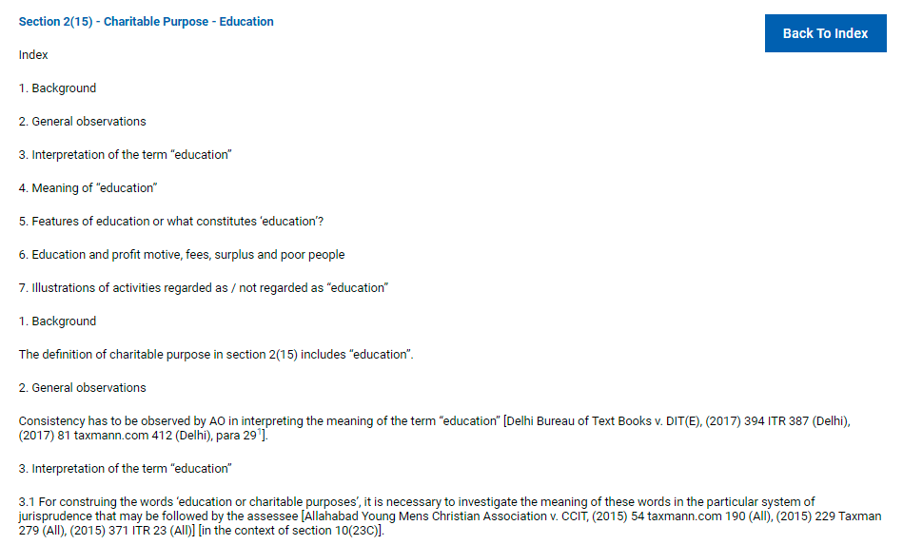

- Search by Checklist

This contains the list of various checklists. A click on a particular checklist will show detailed step plan. The checklists have various features such as ‘Show the Full Checklist’, ‘Show the Completed Checklist’ and ‘Show the Balance Checklist’.

- To view the checklist / step plan, open the ‘Checklist’ page and go through the list.
- Identify the relevant checklist and click on ‘Save Checklist’ button placed in front of it.
- Give desired name to save the checklist. One can use a particular checklist many times by saving it with different name.
- Once it is saved, click on ‘My Account’ button on top right corner and then click on ‘My Checklists’.
- On ‘My checklist’ all the checklists saved can be seen.
- A click on desired checklist will open the checklist as follows (e.g. checklist for drafting MOA):

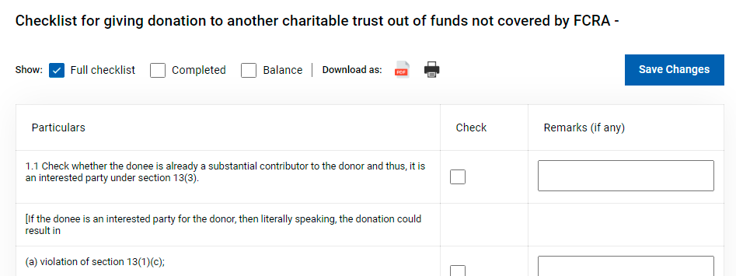

- Search By Question:

The Referencer contains more than 410 questions. From each topic, a few questions have been selected.

Search by question could be used for search on a particular section or by a keyword or for searching illustrations, using search and refine search features (e.g. illustrations of business, illustrations of application of income, etc.)

Illustration:

Question: Illustrations of business

Keyword / phrase in above question (say): illustration + business

  - Type the words ‘illustration’ and ‘business’ in ‘Enter text here’ and click on ‘Search’ button. The following screen containing all questions with ‘illustration’ and ‘business’ will appear:

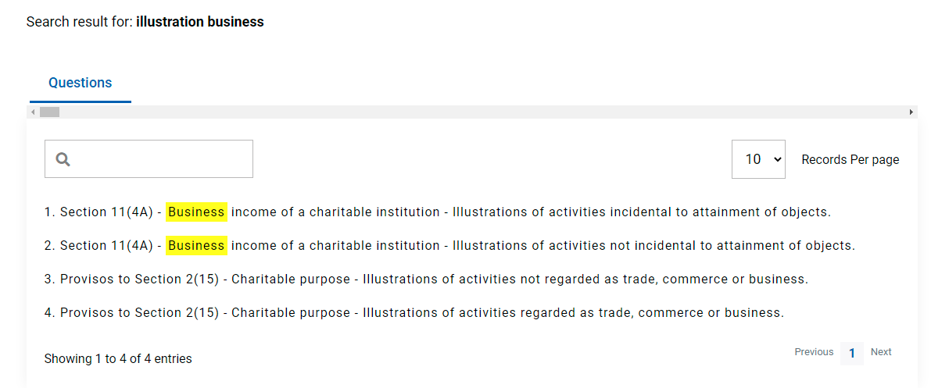

  - Go through the questions and identify your relevant question. Once you have identified your relevant question, click on it. In above case, question no. 4 is relevant. After clicking the question, following screen will appear:

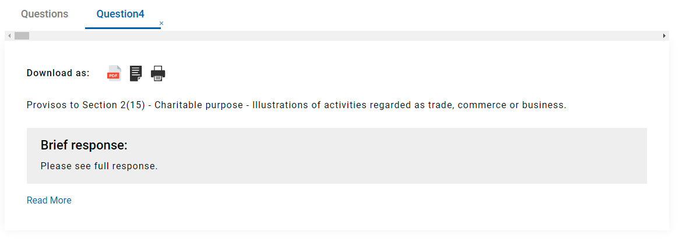

  - After clicking on ‘Read More’ button, following screen will appear:

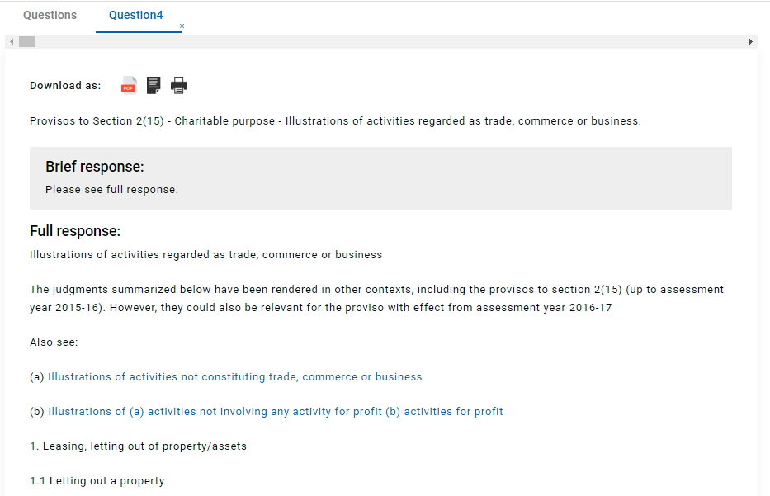

- By Full Text

The full database is searched under this option.

